Kubernetes-04
- Deploy an application using a Deployment with 3 replicas and a rolling update strategy.

Step 1 — Create the Deployment YAML
Run on k8s-master:
vi nginx-deployment.yaml and add

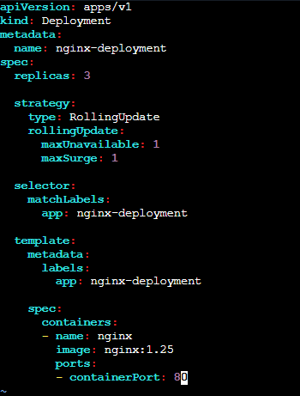
Save and exit.

Step 2 — Create the Deployment
kubectl apply -f nginx-deployment.yaml
Expected:
deployment.apps/nginx-deployment created

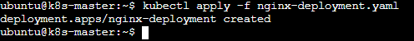

Step 3 — Check the Deployment
kubectl get deployment
Expected:
NAME READY UP-TO-DATE AVAILABLE
nginx-deployment 3/3 3 3

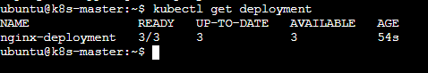

Step 4 — Check the Pods
kubectl get pods -l app=nginx-deployment -o wide
You should see 3 Pods, all Running:
nginx-deployment-xxxxx 1/1 Running
nginx-deployment-yyyyy 1/1 Running
nginx-deployment-zzzzz 1/1 Running

Step 5 — Verify the rolling update strategy
Run:
kubectl get deployment nginx-deployment -o yaml | grep -A5 strategy
You should see:
strategy:
rollingUpdate:
maxSurge: 1
maxUnavailable: 1
type: RollingUpdate
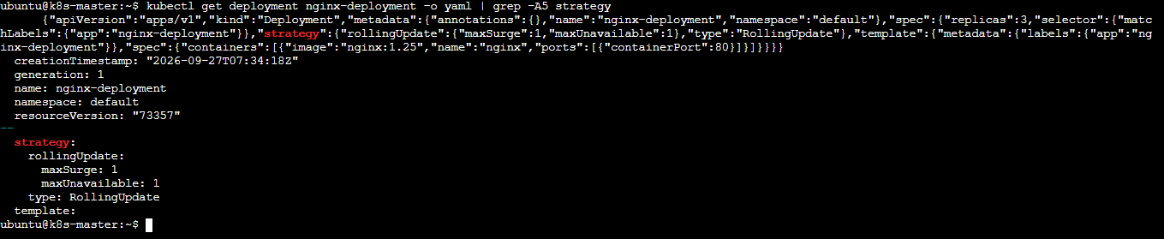

Step 6 — Perform a rolling update
Now change the Nginx version from: image: nginx:1.25
to:
image: nginx:1.26

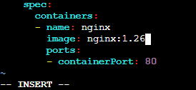

Edit it: vi nginx-deployment.yaml
Change only the image line: image: nginx:1.26
Save and apply:
kubectl apply -f nginx-deployment.yaml
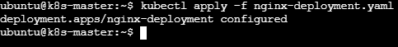

Step 7 — Watch the rolling update
Immediately run:
kubectl rollout status deployment/nginx-deployment
Expected:
deployment "nginx-deployment" successfully rolled out

You can also watch the Pods:
kubectl get pods -l app=nginx-deployment -w
You'll see old Pods being terminated and new Pods being created.
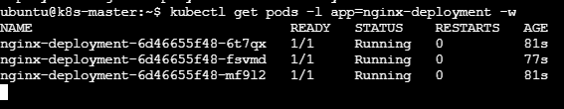
Press: Ctrl+C when the update is complete.

Step 8 — Verify the final state
kubectl get deployment nginx-deployment
Expected:
NAME READY UP-TO-DATE AVAILABLE
nginx-deployment 3/3 3 3

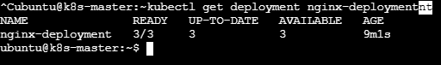
Check the image: All 3 Pods should show:
nginx:1.26
2. Configure a Deployment with a Recreate strategy and observe the downtime.

Step 1. Create the Deployment
Run on k8s-master: vi nginx-recreate.yaml and add
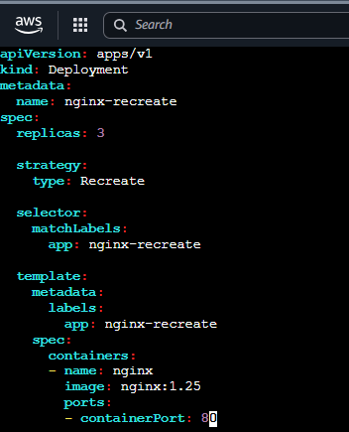
Save and exit.

Step 2. Create the Deployment
kubectl apply -f nginx-recreate.yaml
Expected:
deployment.apps/nginx-recreate created

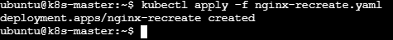
Check:
kubectl get deployment nginx-recreate
You should see:
NAME READY UP-TO-DATE AVAILABLE
nginx-recreate 3/3 3 3

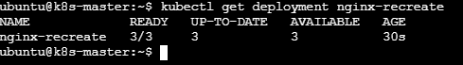

Step 3. Check the Pods
kubectl get pods -l app=nginx-recreate -o wide
You should have 3 Pods:

Step 4. Observe the Recreate strategy
Now change the image from:
image: nginx:1.25
to:
image: nginx:1.26
Edit:
vi nginx-recreate.yaml

Then apply:
kubectl apply -f nginx-recreate.yaml
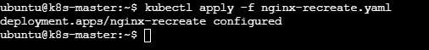

Step 5: Watch the Pods
Immediately run:
kubectl get pods -l app=nginx-recreate –w

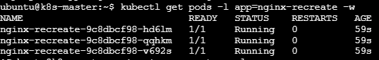

Step 6. Verify the strategy
Run:
kubectl get deployment nginx-recreate -o yaml | grep -A3 strategy
Expected:
strategy:
type: Recreate
And verify the final state:
kubectl get deployment nginx-recreate
kubectl get pods -l app=nginx-recreate
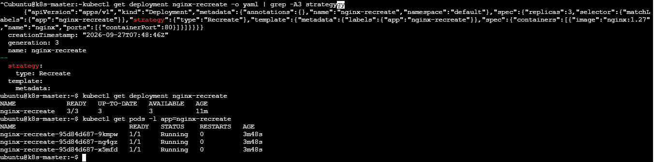

3. Update an existing Deployment and perform a rollback to the previous version.

Step 1 — Check your existing Deployment
Run on k8s-master:
kubectl get deployment nginx-deployment

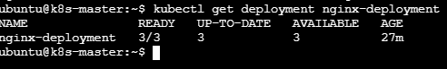
Then check the current image:
kubectl get deployment nginx-deployment -o jsonpath='{.spec.template.spec.containers[0].image}'; echo
If it shows:
nginx:1.26 we can use that as the current version.

Step 2 — Check rollout history
kubectl rollout history deployment/nginx-deployment
You should see something similar to:
deployment.apps/nginx-deployment
REVISION CHANGE-CAUSE
1 <none>
2 <none>
If you only see one revision, that's okay—we'll create another one.
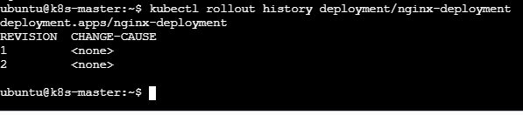

Step 3 — Update the Deployment
Change the image to a new version:
kubectl set image deployment/nginx-deployment nginx=nginx:1.27
You should get:
deployment.apps/nginx-deployment image updated

Step 4 — Watch the rollout
kubectl rollout status deployment/nginx-deployment
Expected: deployment "nginx-deployment" successfully rolled out

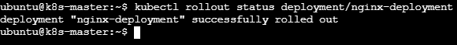
Check the Pods: kubectl get pods -l app=nginx-deployment
All 3 should be Running.
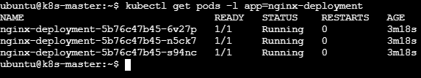

Step 5 — Verify that version 1.27 is running

Step 6 — Check rollout history
kubectl rollout history deployment/nginx-deployment
You should now have at least two revisions.
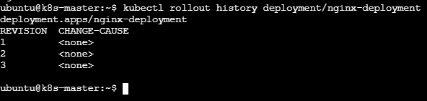

Step 7 — Roll back to the previous version
Run:
kubectl rollout undo deployment/nginx-deployment
Expected:
deployment.apps/nginx-deployment rolled back

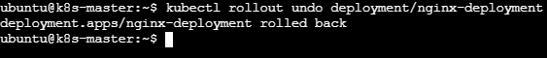

Step 8 — Wait for rollback to complete
kubectl rollout status deployment/nginx-deployment
Expected:
deployment "nginx-deployment" successfully rolled out

Step 9 — Verify the rollback
Check the image:
kubectl get deployment nginx-deployment -o jsonpath='{.spec.template.spec.containers[0].image}'; echo
It should now show the previous version, for example:
nginx:1.26

Also check:
kubectl get pods -l app=nginx-deployment
You should have:
3 Pods
3/3 Ready
Running
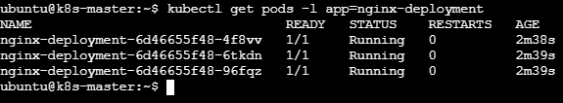

Step 10 — Check rollout history again
kubectl rollout history deployment/nginx-deployment
You should now see multiple revisions.
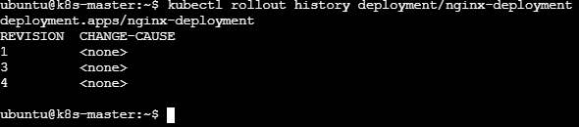
4. Modify a Deployment to add resource requests and limits for CPU and memory.

Step 1. Check the current Deployment
Run on k8s-master:
kubectl get deployment nginx-deployment

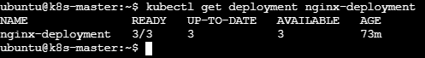
Then check the current resources:
kubectl get deployment nginx-deployment -o yaml | grep -A8 resources
If nothing is displayed, the Deployment currently has no resource requests/limits configured.
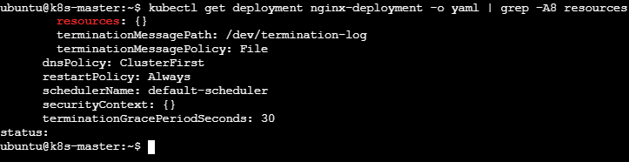

Step 2. Edit the Deployment
Add the resource settings directly using command
Run:
kubectl set resources deployment nginx-deployment \
--requests=cpu=100m,memory=128Mi \
--limits=cpu=250m,memory=256Mi

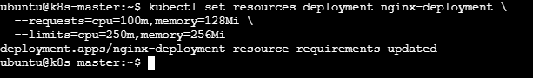

Step 3 — Check the rollout
kubectl rollout status deployment/nginx-deployment
You should see: deployment "nginx-deployment" successfully rolled out

Step 4 — Verify
kubectl describe deployment nginx-deployment
Look for:
Requests:
cpu: 100m
memory: 128Mi
Limits:
cpu: 250m
memory: 256Mi
Or use:
kubectl get deployment nginx-deployment -o yaml | grep -A8 resources

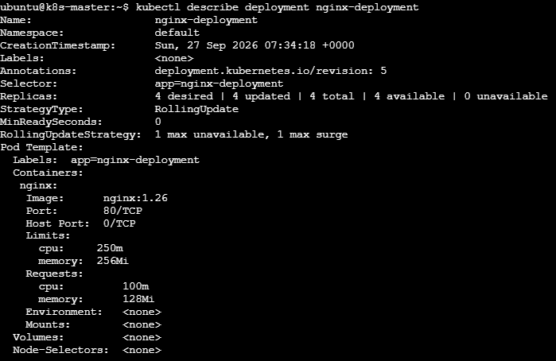
5. Create a Deployment with MaxSurge and MaxUnavailable configurations.

Step 1: Create the YAML file
On k8s-master: vi maxsurge-maxunavailable.yaml and add
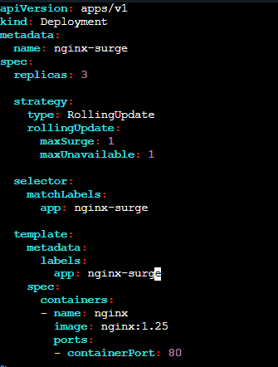
Save and exit.

Step 2: Create the Deployment
kubectl apply -f maxsurge-maxunavailable.yaml
Expected:
deployment.apps/nginx-surge created

Step 3: Verify
kubectl get deployment nginx-surge
You should see approximately:
NAME READY UP-TO-DATE AVAILABLE AGE
nginx-surge 3/3 3 3 ...
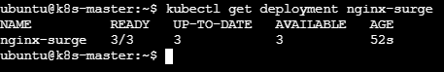

Step 4: Verify MaxSurge and MaxUnavailable
Run:
kubectl get deployment nginx-surge -o yaml | grep -A5 rollingUpdate
Expected:
rollingUpdate:
maxSurge: 1
maxUnavailable: 1

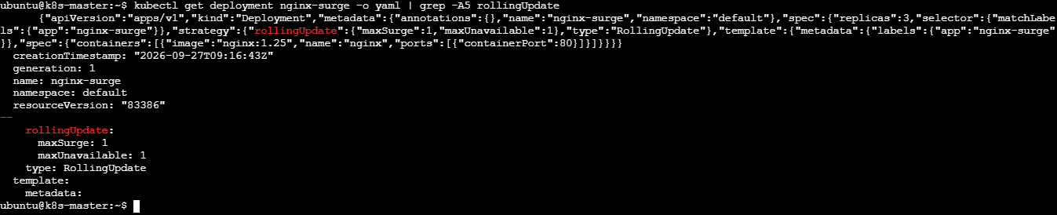
With 3 replicas:
- maxSurge: 1 → Kubernetes can temporarily create 1 extra Pod, so maximum can be 4 Pods during the update.
- maxUnavailable: 1 → Kubernetes can have at most 1 Pod unavailable during the update.

Step 5: Demonstrate the rolling update
Change the Nginx version:
kubectl set image deployment/nginx-surge nginx=nginx:1.26

Step 6: Watch the update:
Start watching before you update.
Run:
kubectl get pods -l app=nginx-surge -w
Keep this terminal open.
Then open a second terminal connected to k8s-master.
In the second terminal, run:
kubectl set image deployment/nginx-surge nginx=nginx:1.26
Now watch the first terminal carefully.
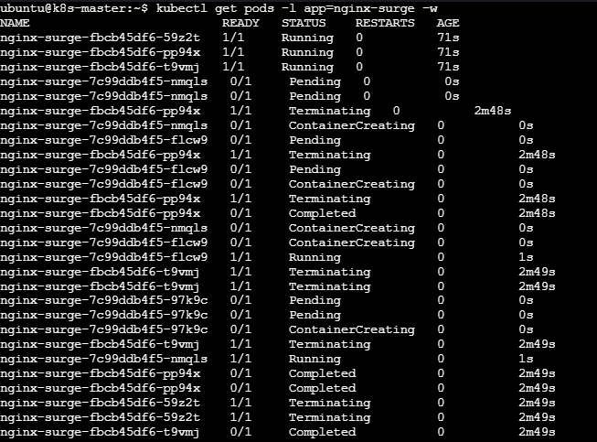
In another command, you can check:
kubectl rollout status deployment/nginx-surge
This demonstrates how maxSurge and maxUnavailable control the number of Pods during a rolling update.
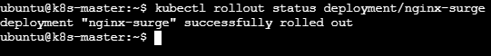
6. Set up a Deployment with a custom revision history limit.

Step 1 — Create the Deployment YAML
On k8s-master:
vi revision-history.yaml and add

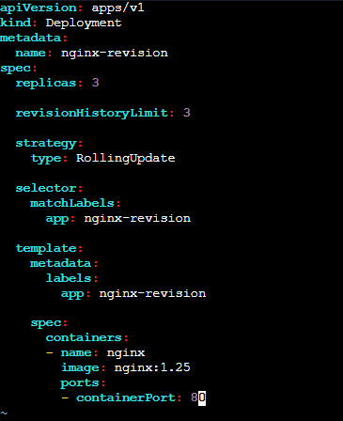

Save and exit.

Step 2 — Create the Deployment
kubectl apply -f revision-history.yaml
Expected:
deployment.apps/nginx-revision created

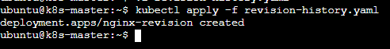

Step 3 — Verify the revision history limit
Run:
kubectl get deployment nginx-revision -o yaml | grep revisionHistoryLimit
Expected:
revisionHistoryLimit: 3

Step 4 — Create a few revisions
A revision is created when you change the Deployment's Pod template, such as changing the image.
First update:
kubectl set image deployment/nginx-revision nginx=nginx:1.26
Wait:
kubectl rollout status deployment/nginx-revision
Second update:
kubectl set image deployment/nginx-revision nginx=nginx:1.27
Wait:
kubectl rollout status deployment/nginx-revision
Now check:
kubectl rollout history deployment/nginx-revision
You should see revisions such as:
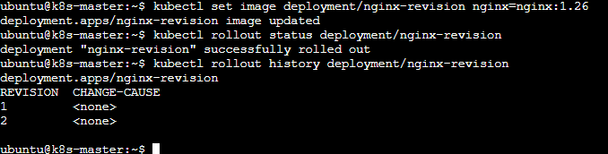
7. Pause a Deployment during an update, and then resume it.

Step 1 — Check the Deployment
On k8s-master:
kubectl get deployment nginx-revision
You should see:
NAME READY UP-TO-DATE AVAILABLE
nginx-revision 3/3 3 3
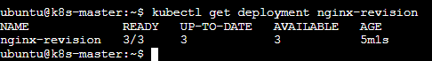

Step 2 — Pause the Deployment
Run:
kubectl rollout pause deployment/nginx-revision
Expected:
deployment.apps/nginx-revision paused
Now Kubernetes will not complete new rollout changes until you resume it.
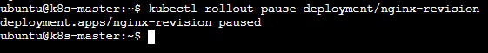

Step 3 — Make an update while it is paused
Change the Nginx version:
kubectl set image deployment/nginx-revision nginx=nginx:1.27
Expected:
deployment.apps/nginx-revision image updated

Now check:
kubectl get deployment nginx-revision

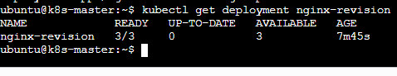
And:
kubectl get pods -l app=nginx-revision
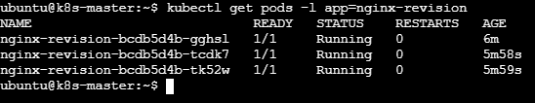
The important point is that the Deployment is paused, so the update will not proceed normally.
You can also verify the pause status:
kubectl get deployment nginx-revision -o yaml | grep paused
Expected:
paused: true

Step 4 — Resume the Deployment
Now resume it:
kubectl rollout resume deployment/nginx-revision
Expected:
deployment.apps/nginx-revision resumed

Step 5 — Watch the rollout
kubectl rollout status deployment/nginx-revision
Expected:
deployment "nginx-revision" successfully rolled out
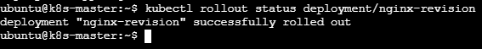
Then check the Pods:
kubectl get pods -l app=nginx-revision
You should have 3 Running Pods.
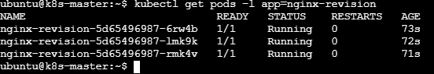
Step 6 — Verify the new image
8. Create a pod using resource requests for memory and CPU, and observe how the scheduler assigns it to a node.

Step 1 — Check your nodes
Run on k8s-master:
kubectl get nodes

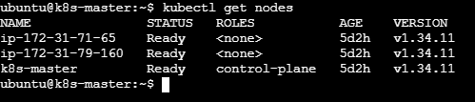

Step 2 — Create the Pod
Create a YAML file:
vi resource-pod.yaml and add

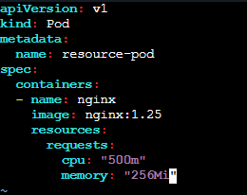

Save and exit.

Step 3 — Create the Pod
kubectl apply -f resource-pod.yaml
Expected:
pod/resource-pod created
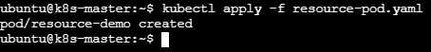

Step 4 — See which node received the Pod
Run:
kubectl get pod resource-pod -o wide
You might see:
NAME READY STATUS IP NODE
resource-pod 1/1 Running 192.168.x.x ip-172-31-71-65
The important column is:
NODE
That tells you which node the scheduler selected.

Step 5 — Observe the resource request
Run:
kubectl describe pod resource-pod
Look for:
Requests:
cpu: 500m
memory: 256Mi
This confirms that the Pod requested those resources.
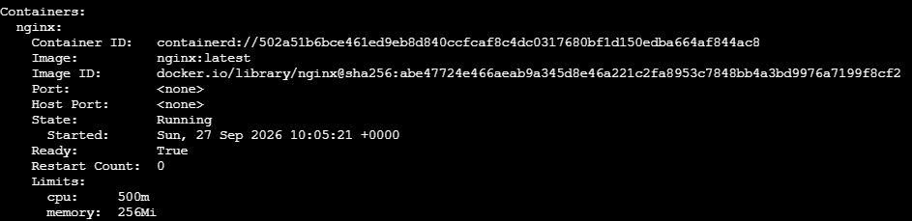

Step 6 — Check the node's resources
Suppose your Pod was assigned to:
ip-172-31-71-65
Run:
kubectl describe node ip-172-31-71-65
Look near the bottom for:
Allocated resources:
Resource Requests
-------- --------
cpu ...
memory ...
This lets you observe that the Pod's 500m CPU and 256Mi memory request are accounted for on that node.
